TITLE: - COMMITTING BASICS EXCERCISE
AIM: - To perform basic commit in git and some functionalities
DESCRIPTION:
- Creating new folder
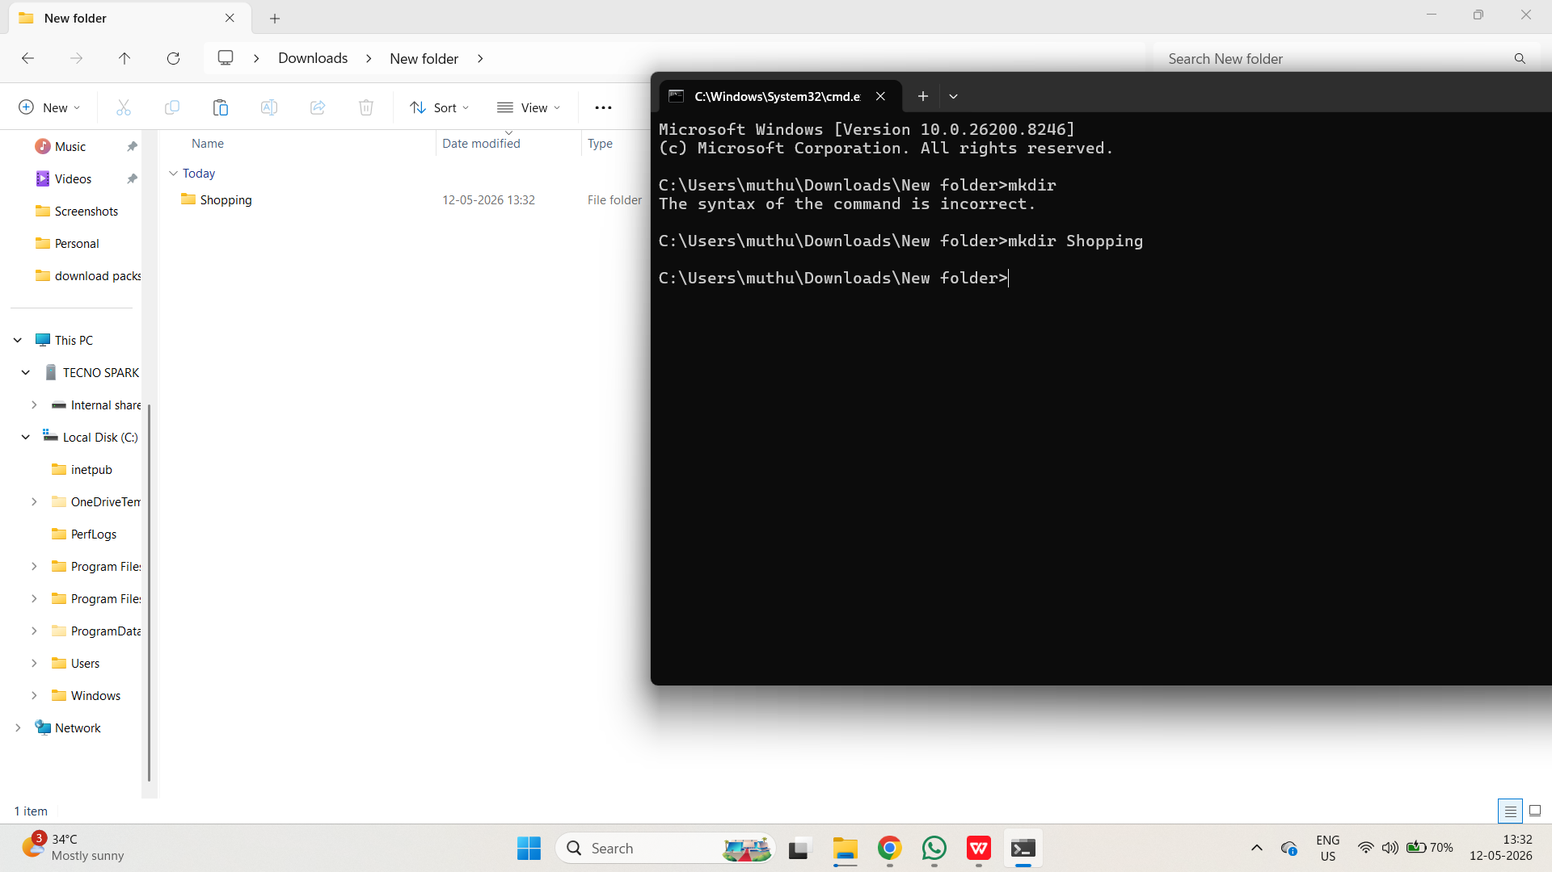
- Move to the repository and initialize it
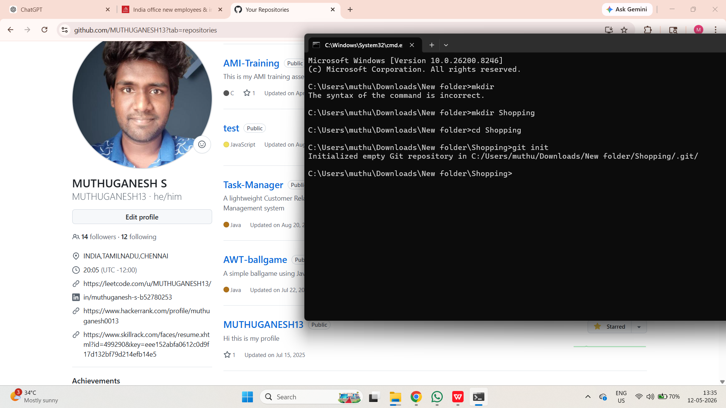
- Make new File
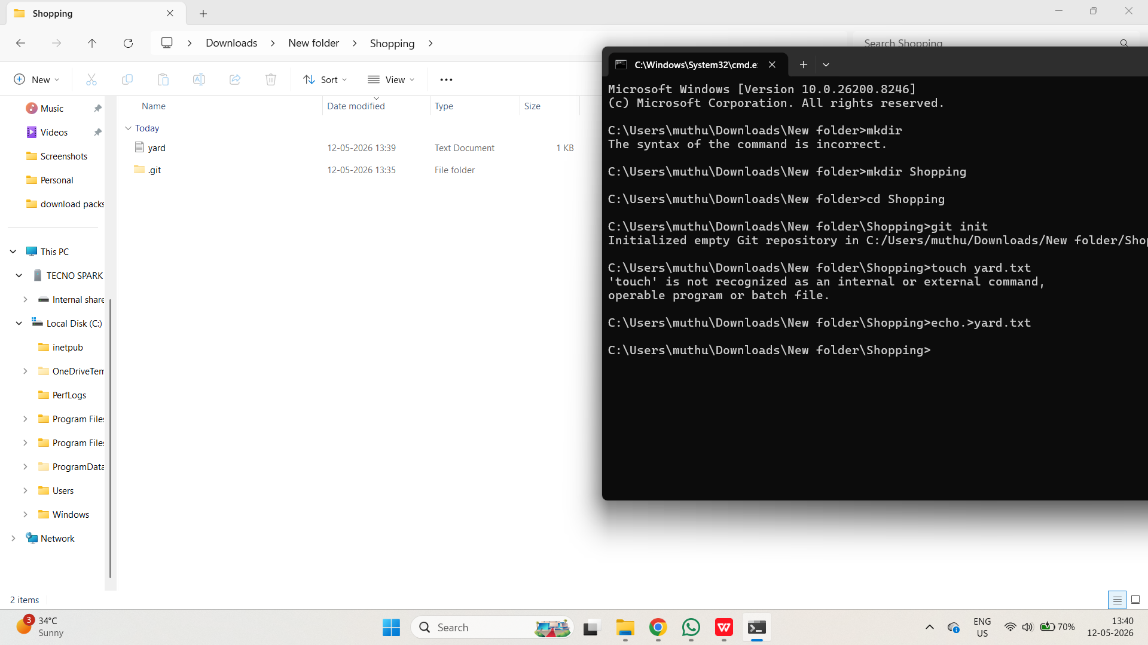
- Make another new file called groceries.txt
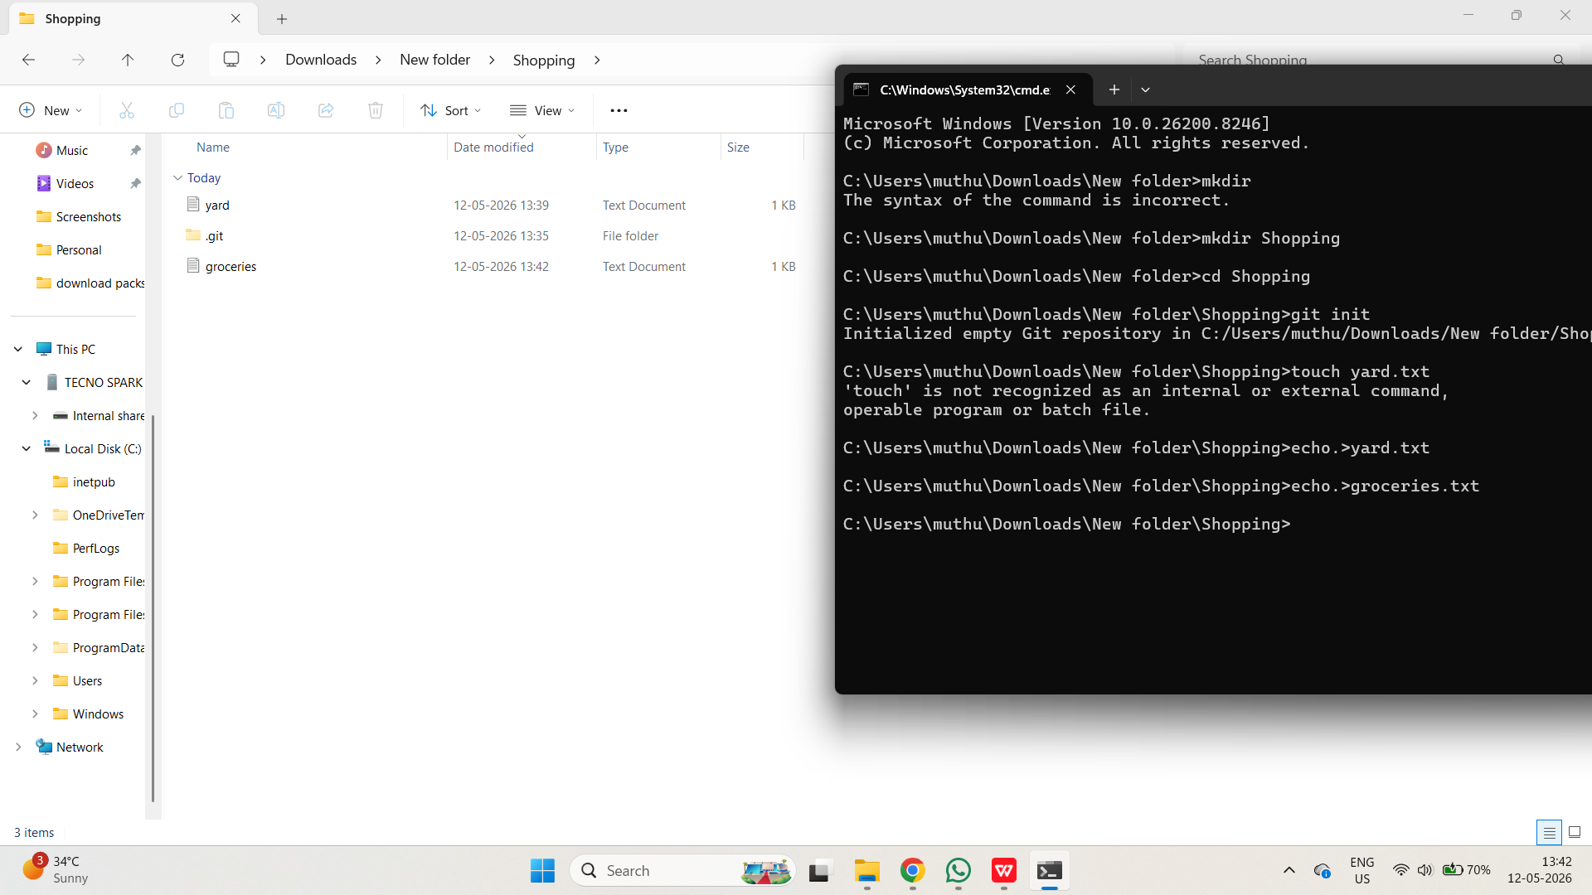
5.Make a commit that includes both empty files. The message should be "create yard and groceries lists"
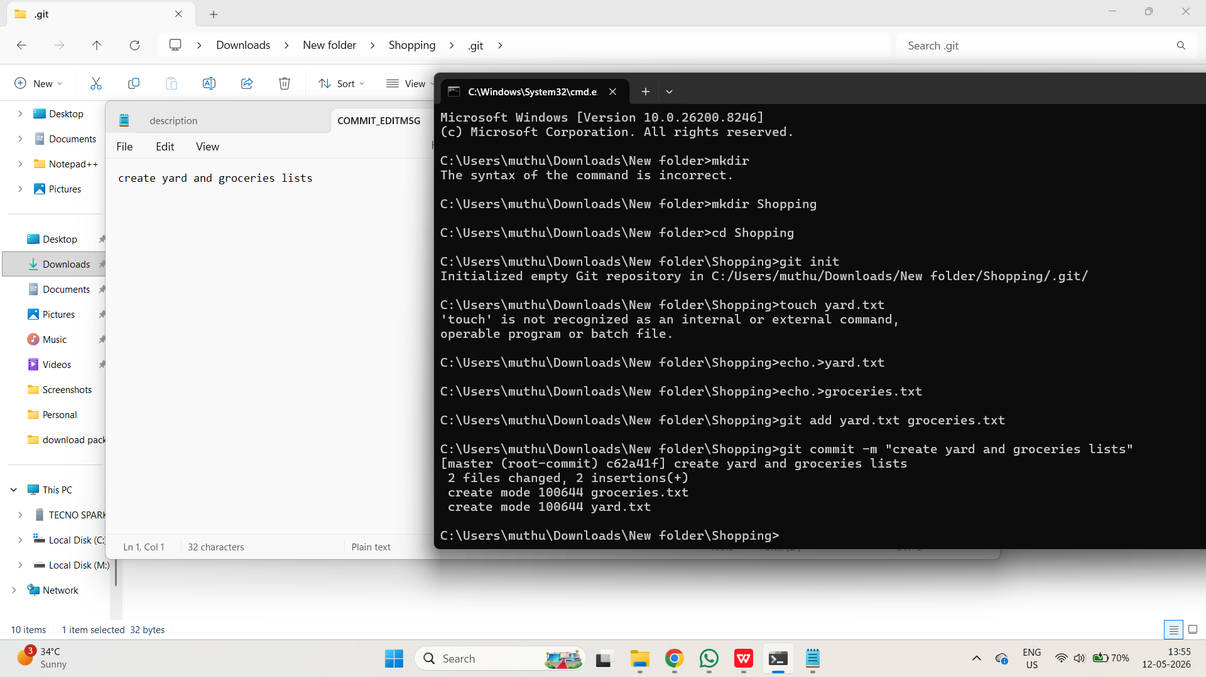
6.In the yard.txt file, add the following changes:
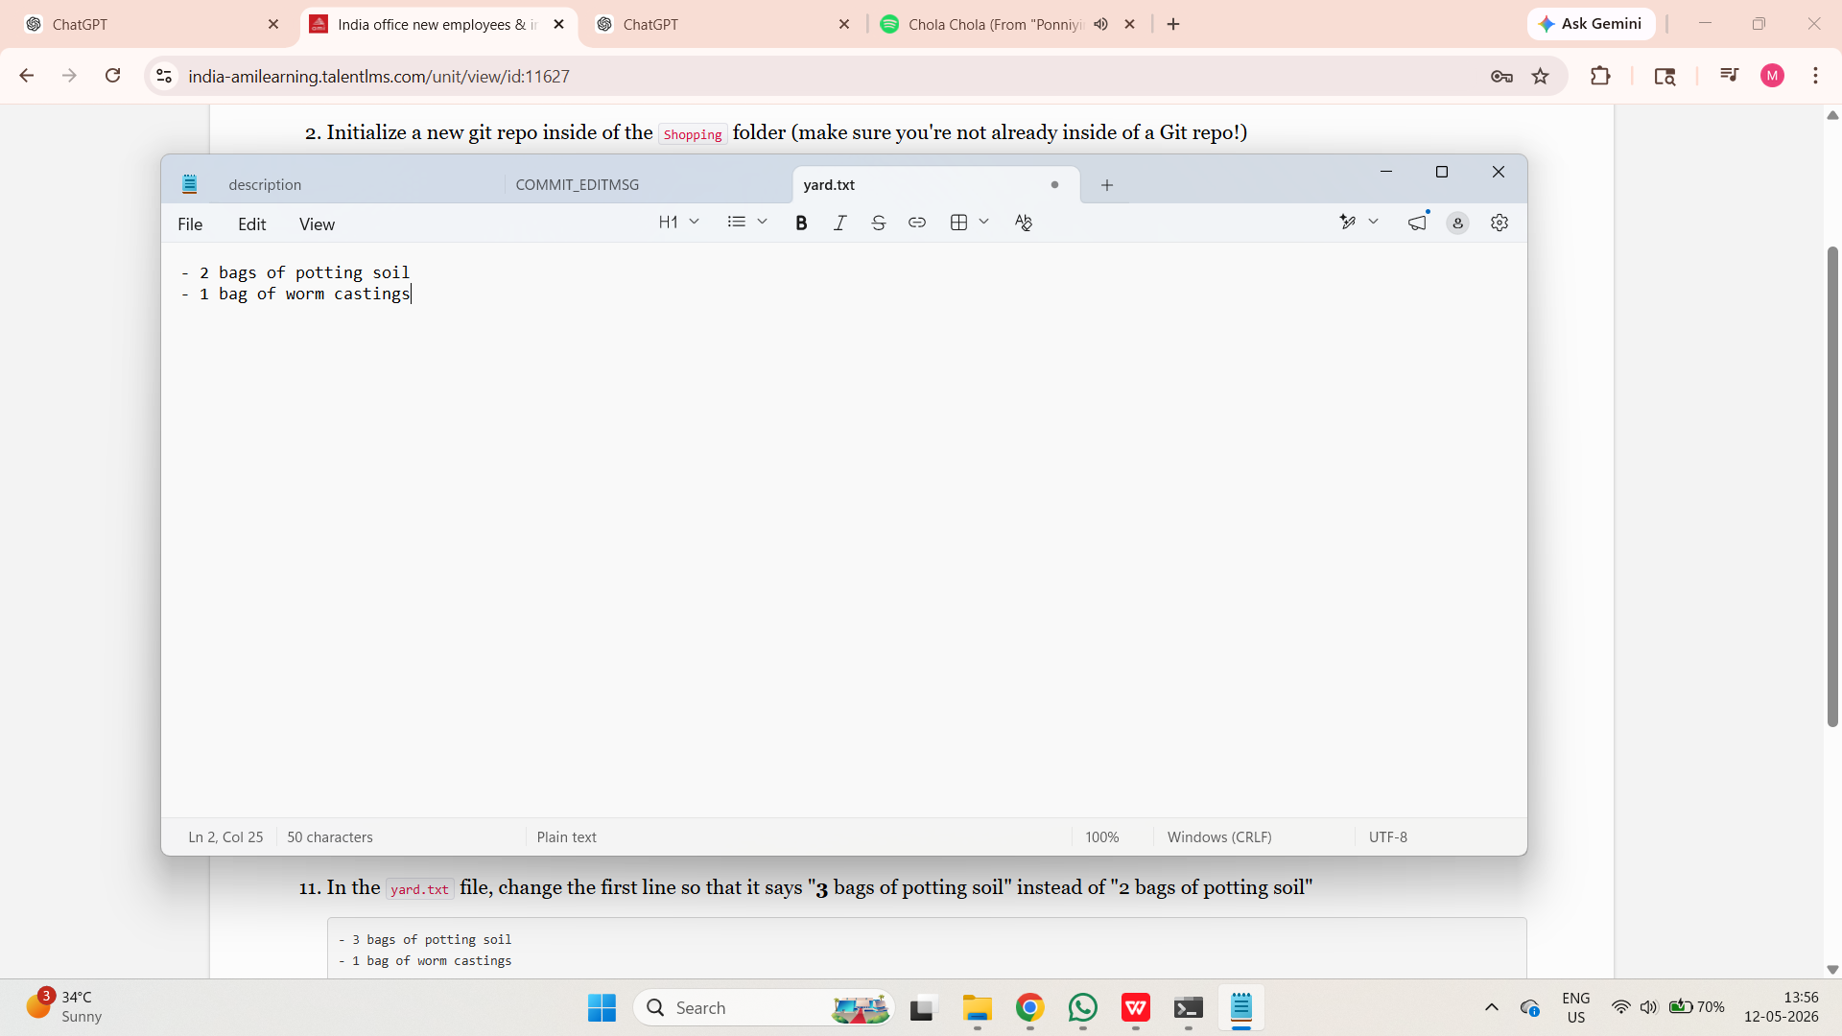
- In the groceries.txt file, add the following:
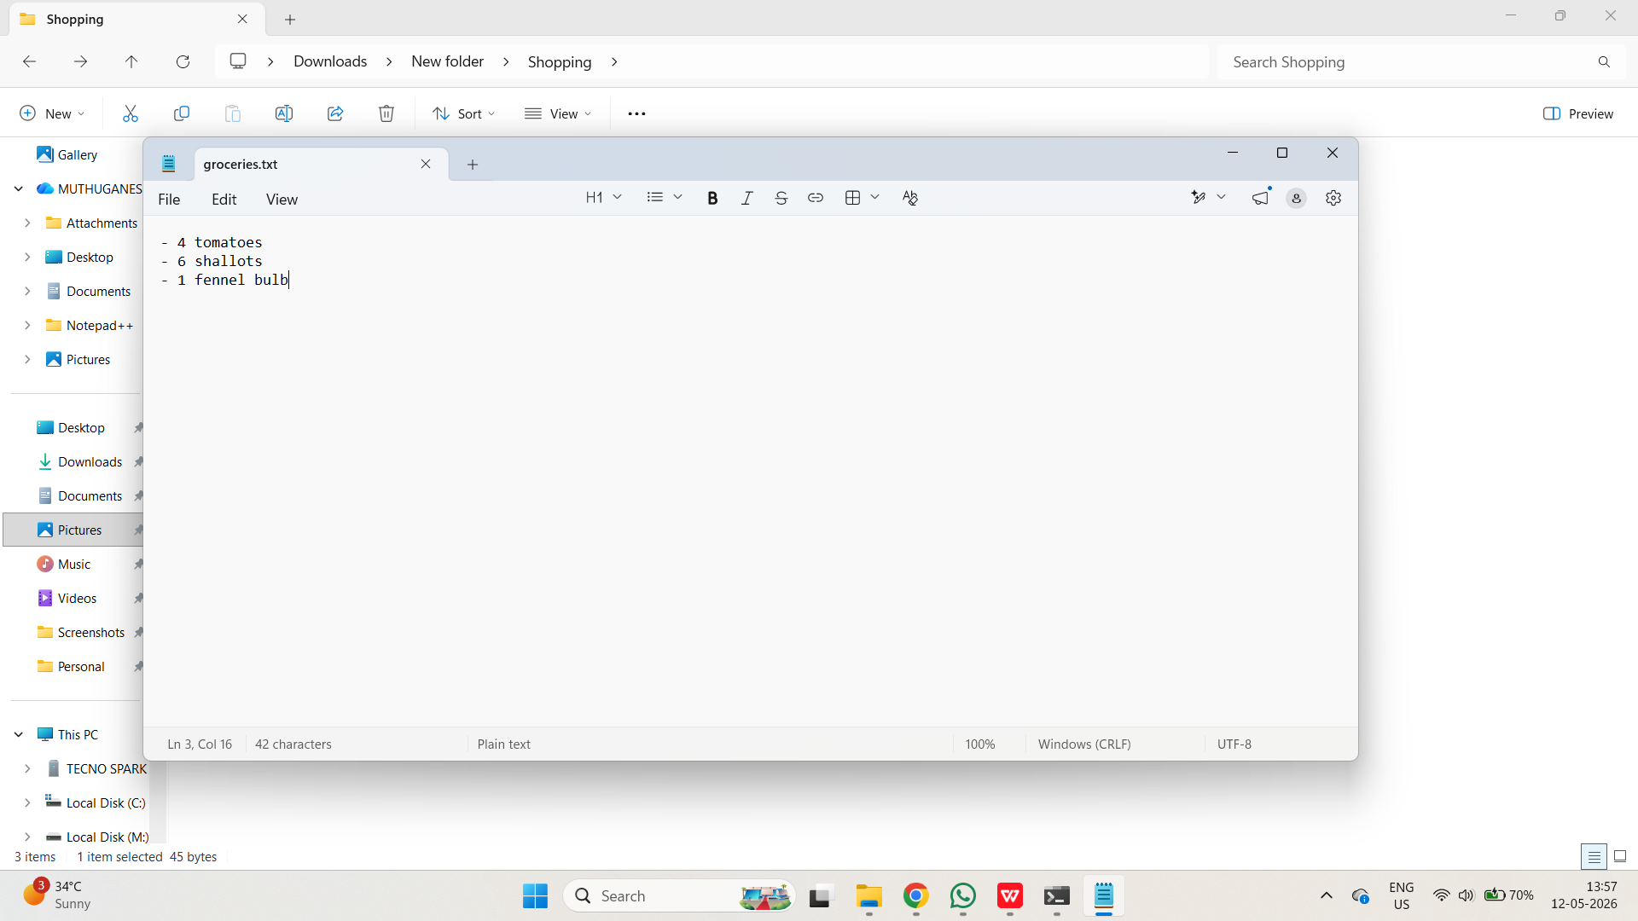
- Make a new commit, including ONLY the changes from the groceries.txt file. The commit message should be "add ingredients for tomato soup"
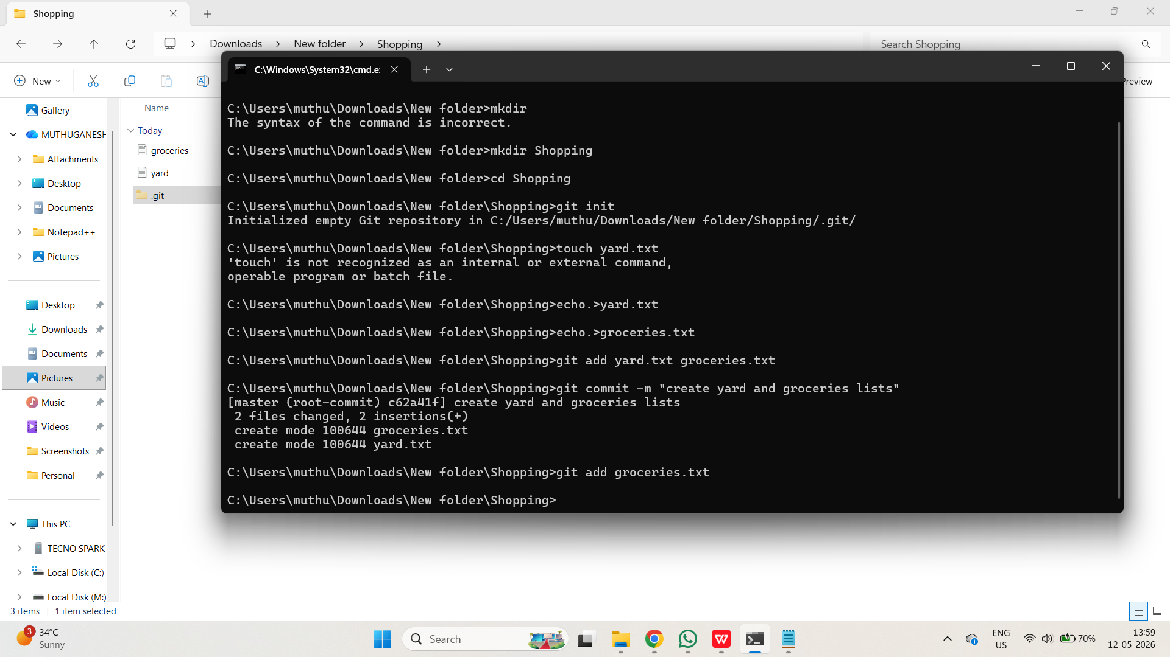
- Make a second commit including ONLY the changes to the yard.txt file. It should have the commit message "add items needed for garden box"
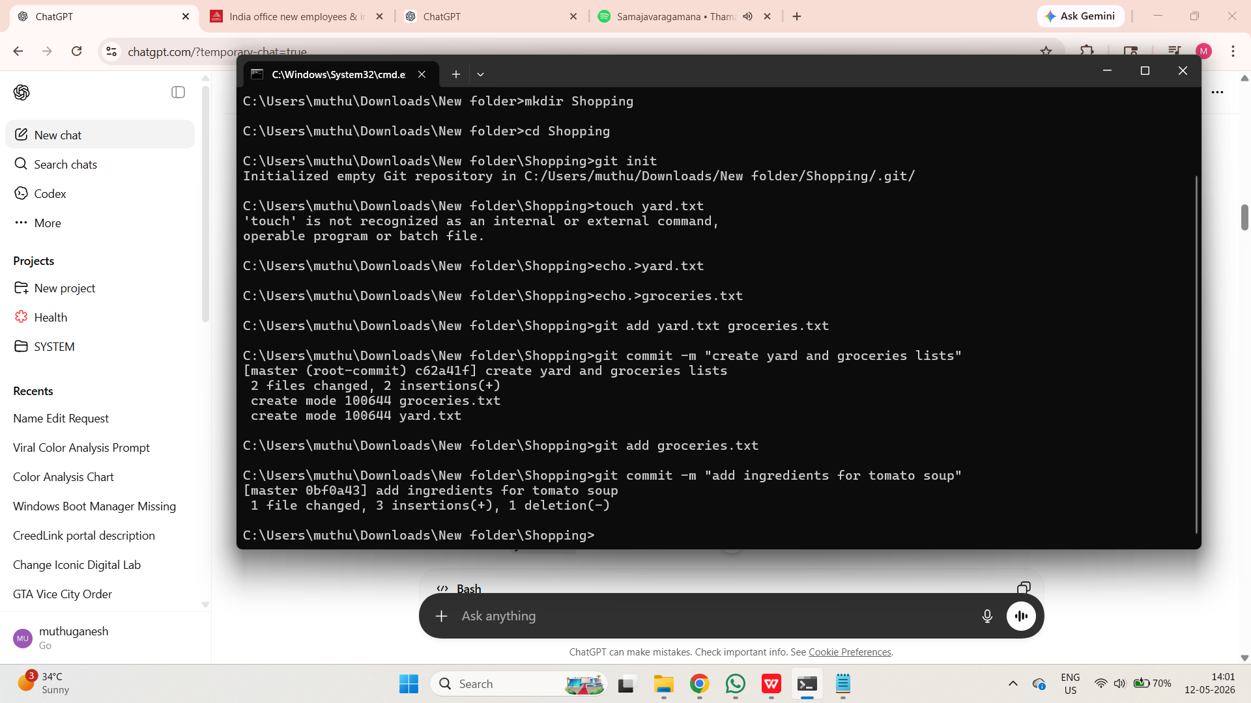
- Next up, add the following line to the end of groceries.txt
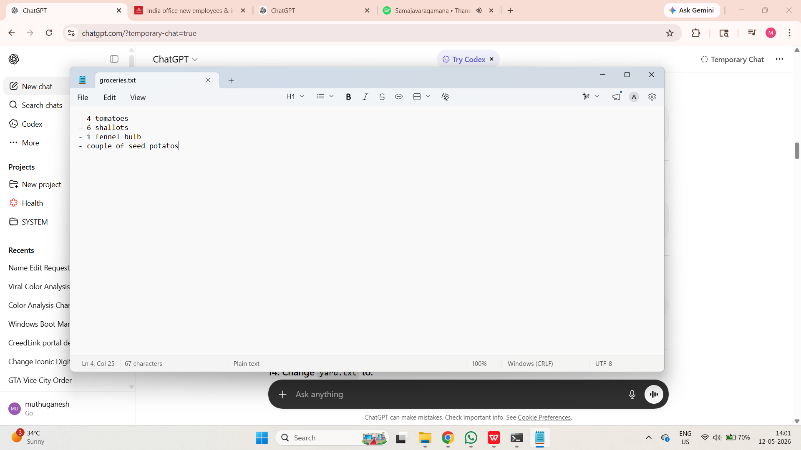
- In the yard.txt file, change the first line so that it says "3 bags of potting soil" instead of "2 bags of potting soil"
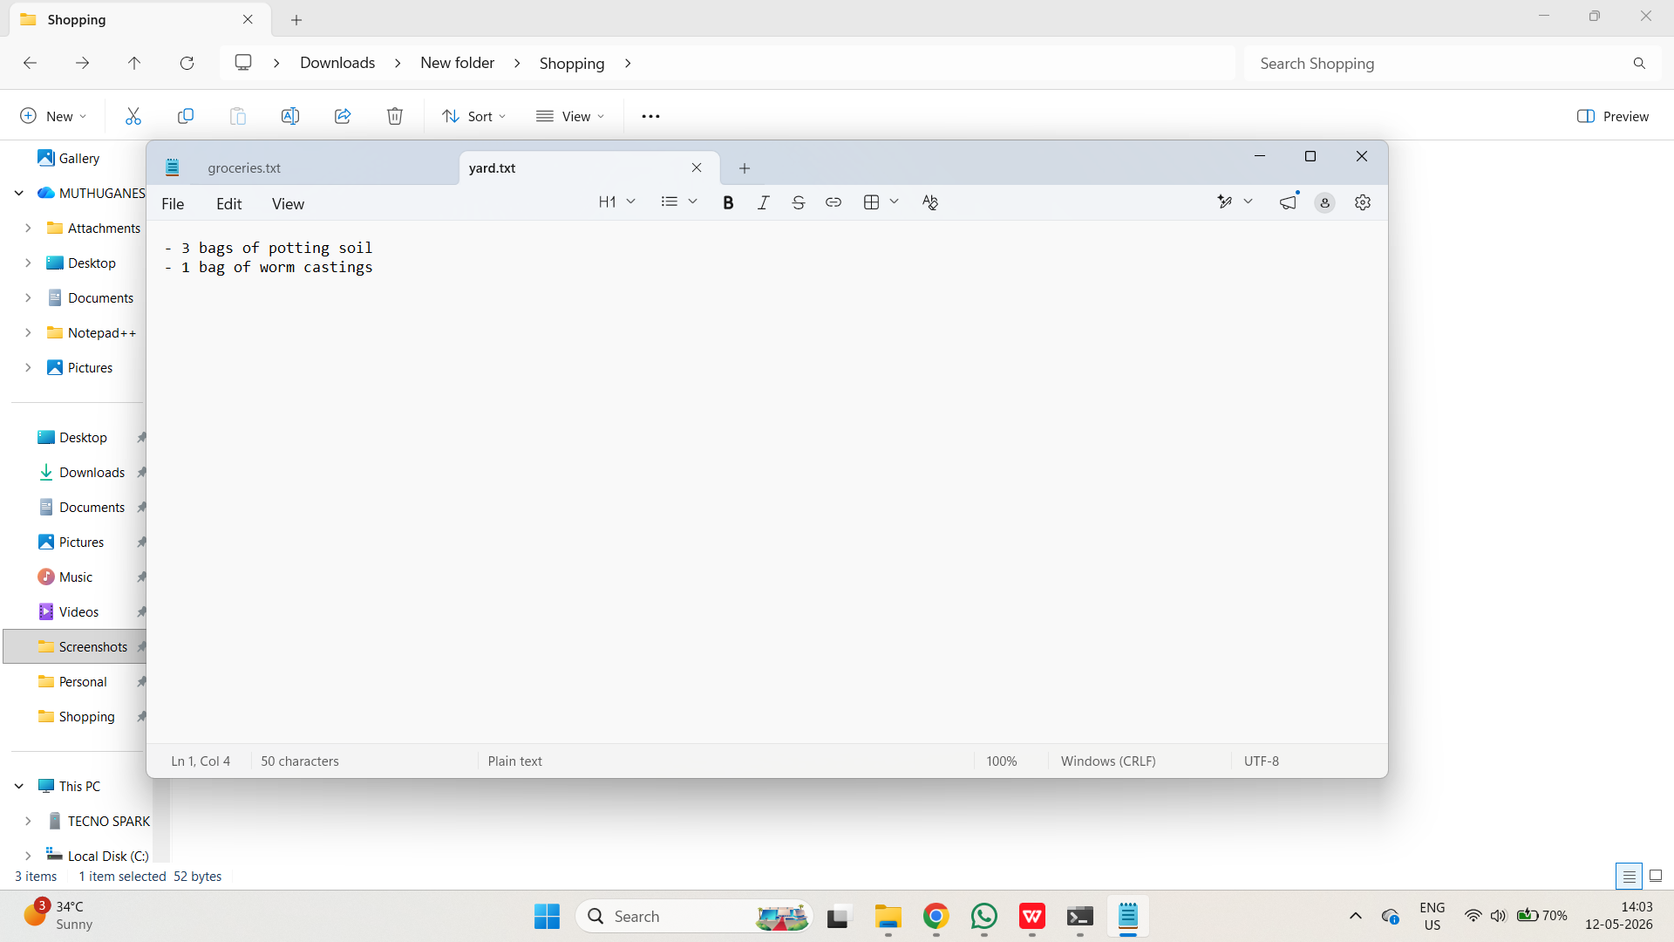
- Make a commit that includes the changes to BOTH files. The message should read "add items needed to grow potatoes"
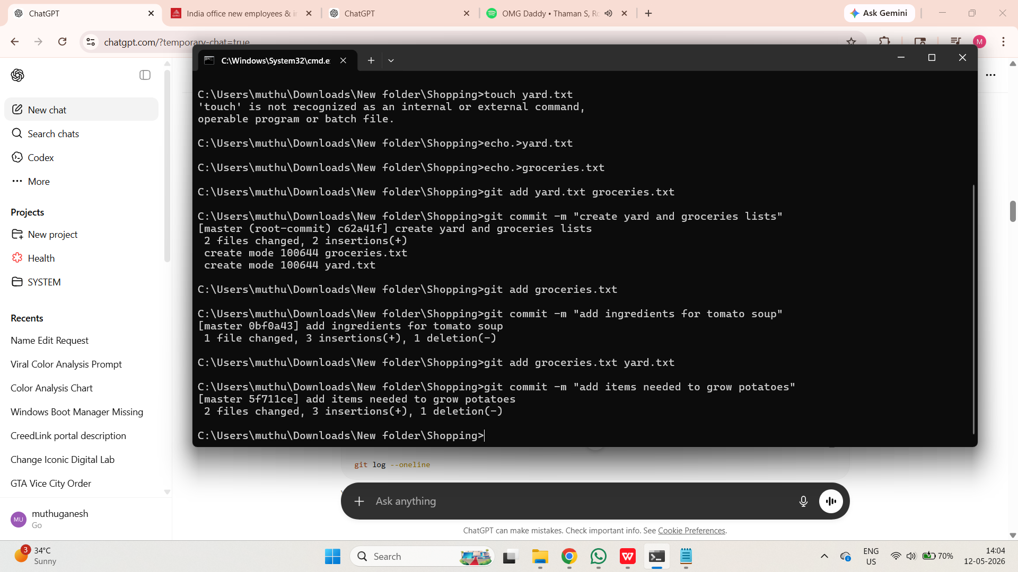
- Use a Git command to display a list of the commits.
